

EE462 & EE464 Project: Design of a SM-PMSM Variable Frequency Drive with Matlab/Simulink

Hakkı GÜLCÜ

Tel: +90 534 397 29 66

mail: [hakkigulcu35@gmail.com](mailto:hakkigulcu35@gmail.com)

2093862

Özgür

Tel: +90 535 938 69 20

mail: [ozgur_6155@hotmail.com](mailto:ozgur_6155@hotmail.com)

2093805

**Supervisor:** Ozan KEYSAN & Emine BOSTANCI

Date of Submission: 02.06.2019

Contents

Introduction 2

Part A: Pre-design Stage 2

Part B: SPWM Design 4

Part D: Component selection and verification 12

References 13

# Introduction

The aim of project is to design a SM-PMSM Variable Frequency Drive with respect to given parameters below by using matlab Simulink program.

𝑃𝑛𝑜𝑚𝑖𝑛𝑎𝑙 = 80 𝑘𝑊

T𝑛𝑜𝑚𝑖𝑛𝑎𝑙 = 300 𝑁𝑚

𝑛𝑚𝑎𝑥 = 7000 𝑟𝑝𝑚

Pole number: p=8

𝐹𝑙𝑢𝑥 𝑙𝑖𝑛𝑘𝑎𝑔𝑒: 𝜆𝑃𝑀 = 0.2 Vs (Wb-t)

𝐿𝑑 = 𝐿𝑞 = 500 uH

𝐼𝑛𝑜𝑚𝑖𝑛𝑎𝑙 = 250 𝐴 (peak)

Phase resistance 𝑅𝑠 = 50 mOhm

Equivalent inertia of the system: 𝐽𝑒𝑞 = 10 kg m2

Ignore windage and friction losses.

The available supply is a three-phase AC source (50 Hz, 400Vl-l) and the PM is a surface-mount motor. Assume a 3-phase full-bridge diode rectifier is connected to the grid.

# Part A: Pre-design Stage

**1)** Calculation of the rated speed and torque of the PMSM.

$$Wbase=\frac{Pnominal}{Tnominal}=\frac{80 kW}{300 Nml}= 266.67 rad/sec , Nbase=2546.48$$

$$T=\frac{3}{2}*pp* λPM*iq Where nomimal base Torque condition, İq=İnominal =250 A , İd=0$$

Then T=1.5*4(pp)*0.2*250 = 300Nm where it is also given in parameters.

**2)** Calculation of the maximum applied electrical frequency and choose a switching frequency for your inverter

$$We=2*π*f , then frequency=\frac{We}{2*π}$$

$$where from part a We(max)= \frac{7000rpm*2*π}{180} is found 733 rad/sec,$$

$$fmax=\frac{733}{2*π}=116.67 Hz$$

Selected Switch frequency=10kHz

**3)**

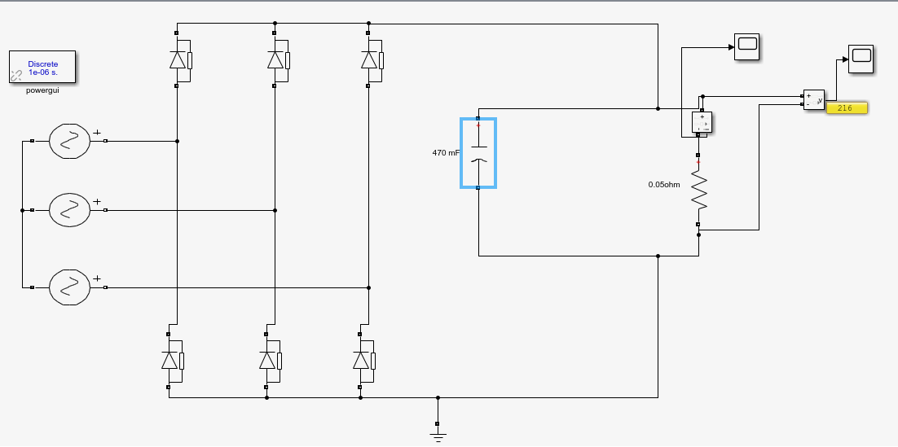

Figure :Design of DC-link filter for the rectifier block

We select the capacitor as 100 mF in order to decreases the voltage ripple.

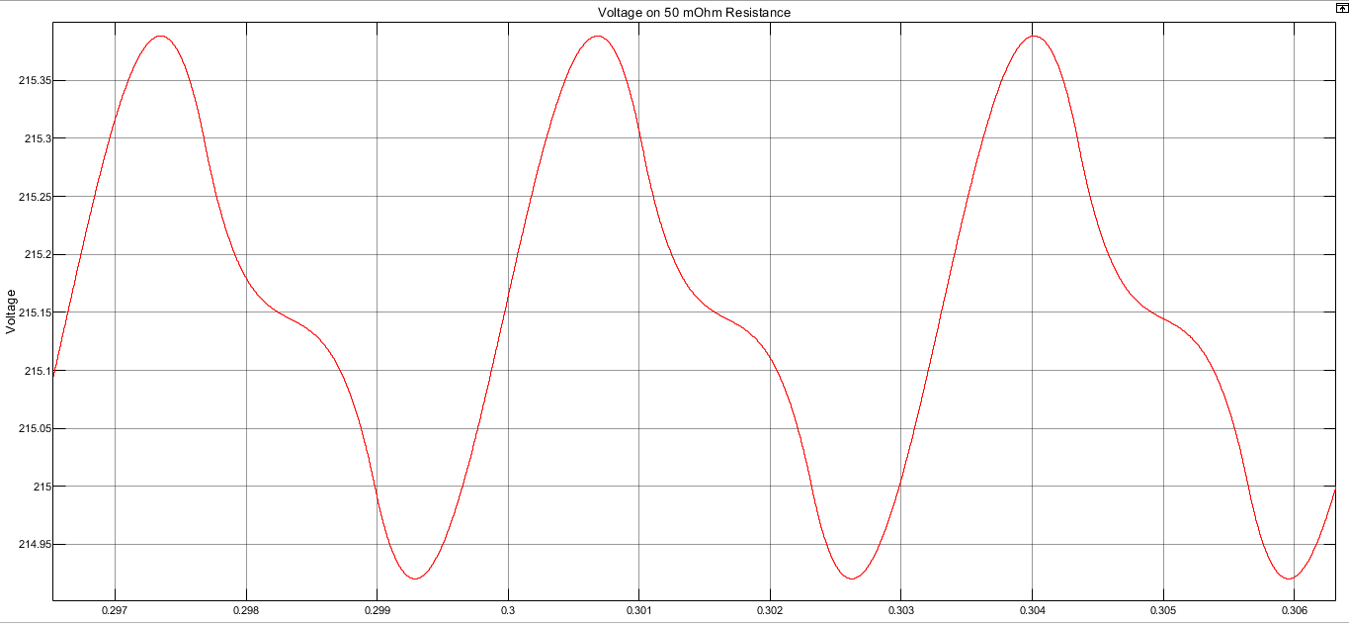

Figure : Plot of the DC-link voltage waveform by connecting a resistive load equivalent to motor.

As seen figure 2. Voltage ripple is about 0.4 V. Avarage DC-link voltage as 215.15 .

Then, Ripple = 100 $\frac{0.4}{215.15}=\%0.2$* , This is so efficient result for our design.

# Part B: SPWM Design

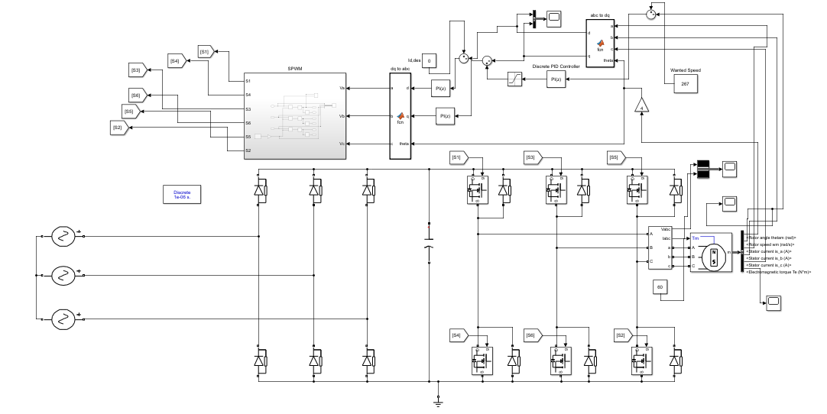

Figure 3. Overall System

1. Graphs are given below;

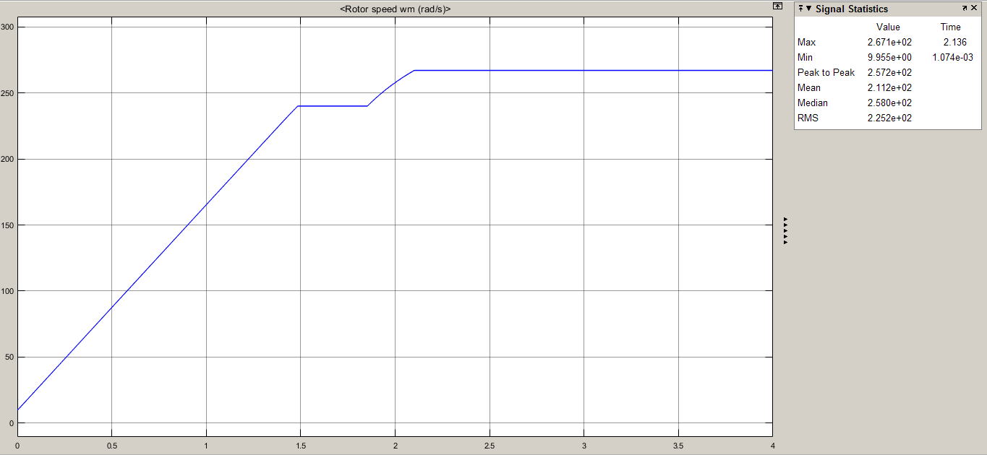

Figure 4. 90% Rated Speed(240 rad/s) to Rated Speed

We had given 240 rad/s first to the reference speed and reach that value and after some milliseconds, we made the ref speed rated speed.

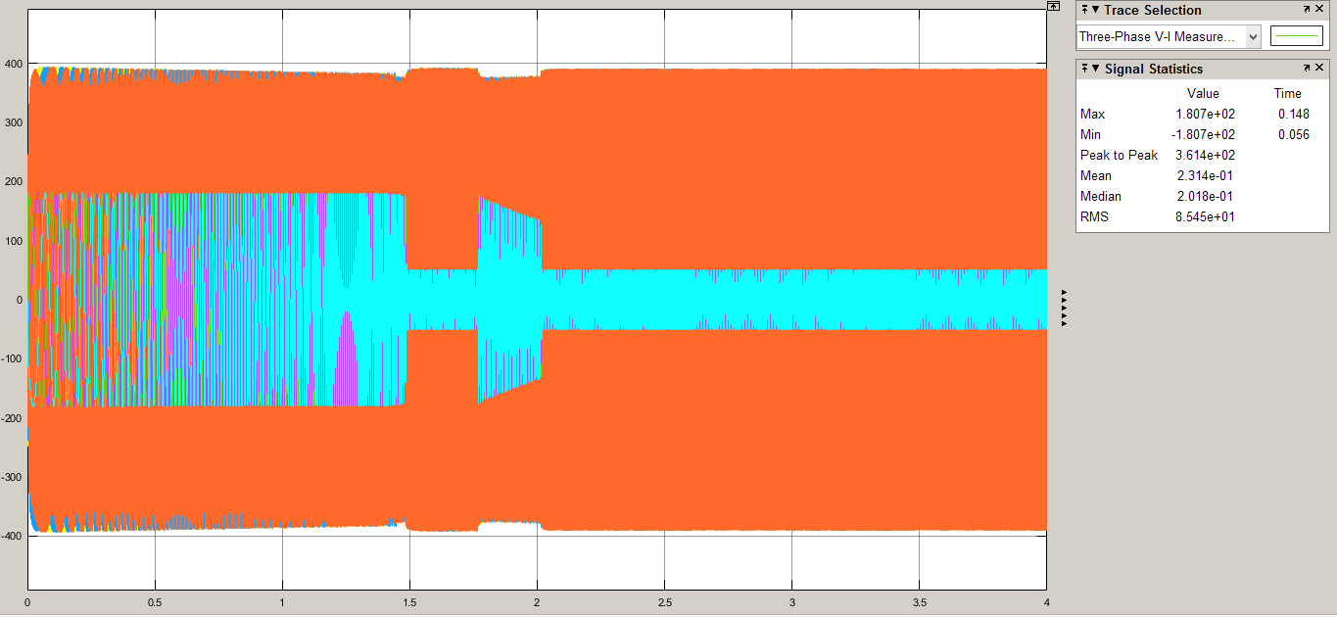

Figure .Vl-l and Iph Waveforms

The phase current is around 180 Apeak until the speed is stable at wanted speed. Then at stable condition, Iph ,peak = 40-50 A,peak. Vl-l does not differ much around the time of stable and switching sequences.

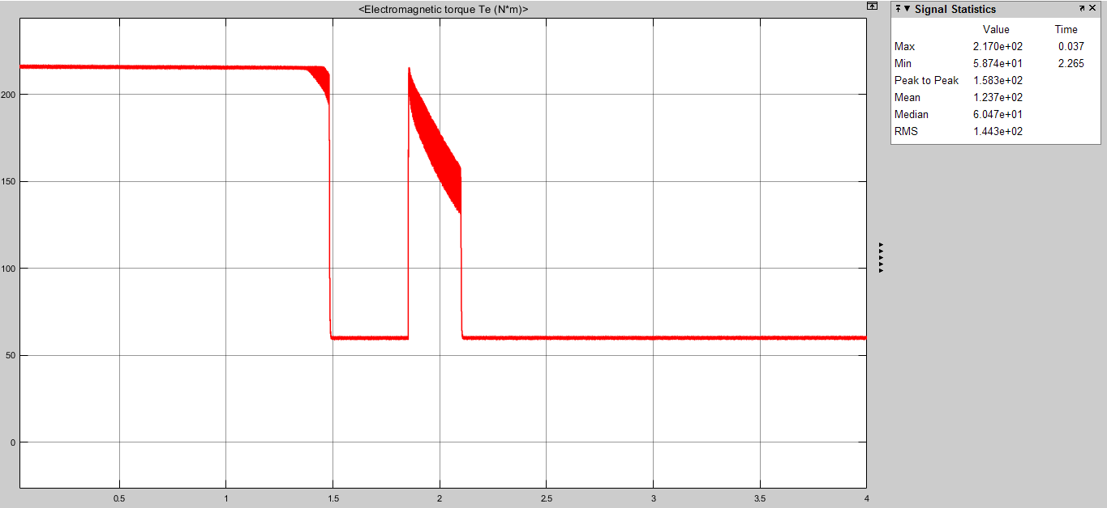

Figure 6. Torque vs. Time

Torque is around 220 Nm at the operation of transient time and then decreases to 60 Nm.

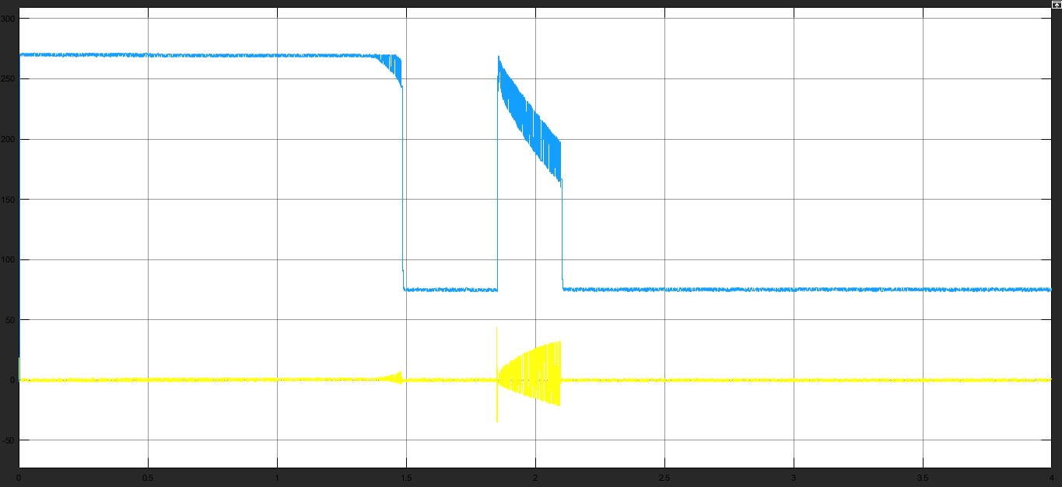

Figure 7. Iq(blue) and Id(yellow) Waveforms

Notice how Iq waveform is similar to Torque waveform and also observe how id changes and oscillates around the rated speed and id begins to be a non-zero value.

1. Load is unloaded around t = 1.9 sec;

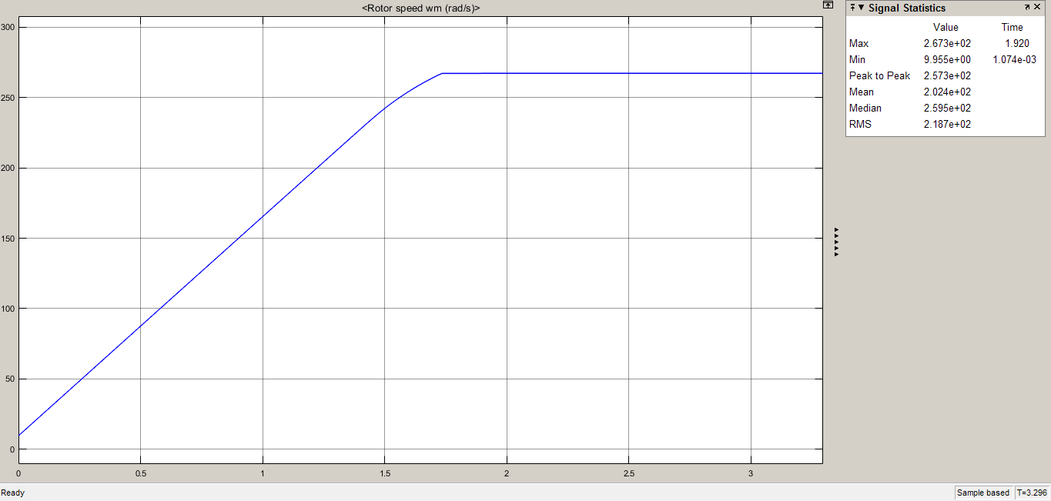

Figure 8. Speed vs. Time

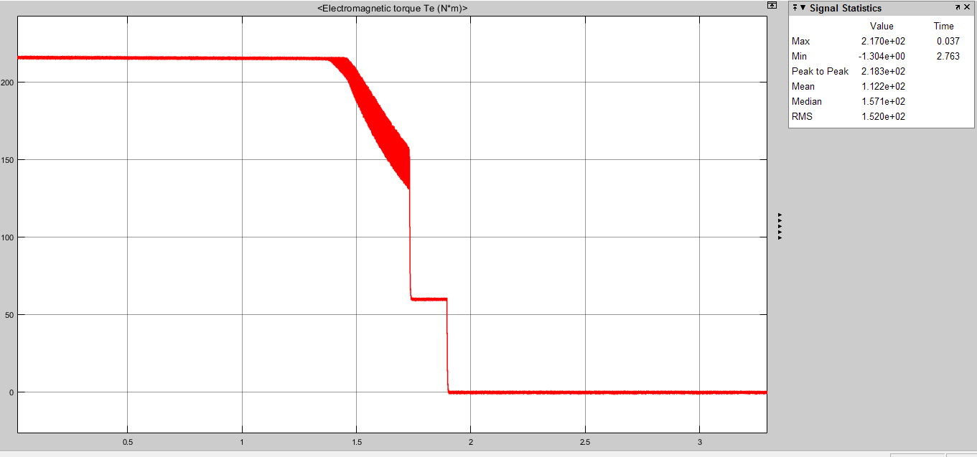

Figure 9. Torque vs. Time

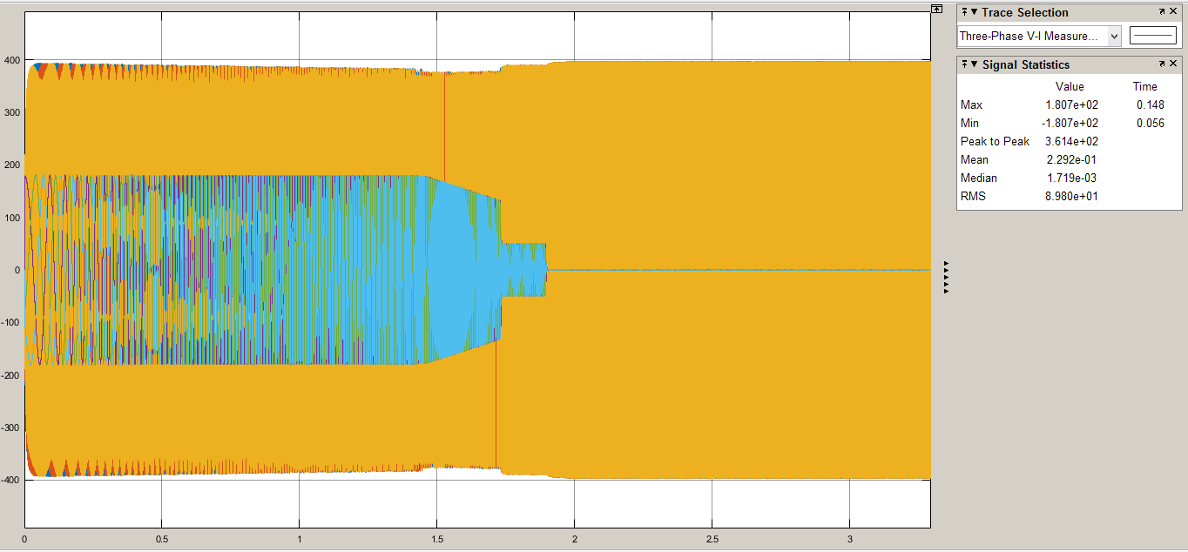

Figure 10. Iph and Vl-l

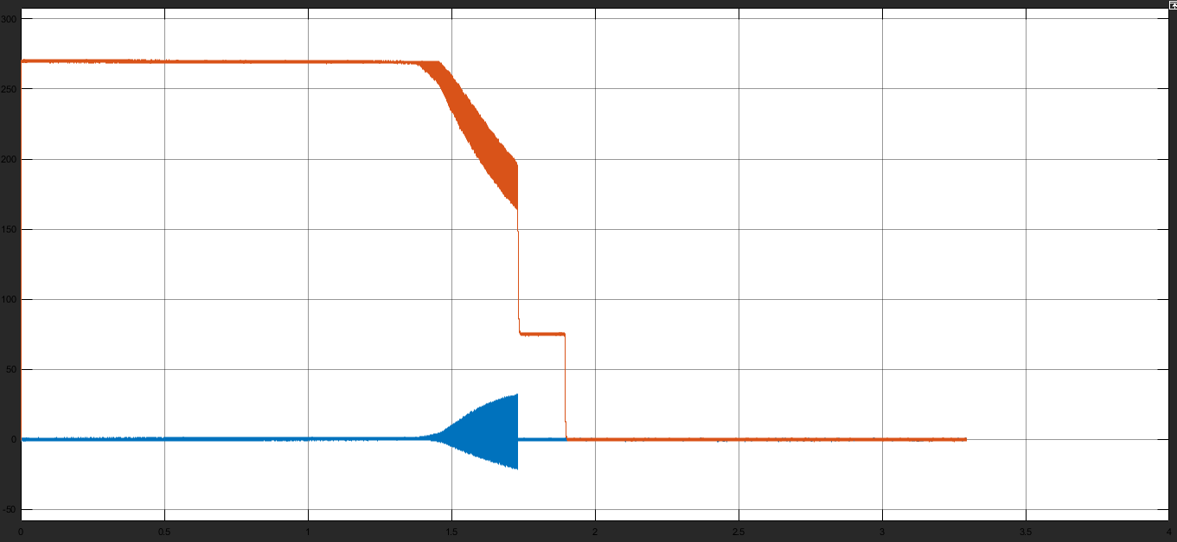

Figure 11. Iq and Id

According to these figures, motor speed stays the same after the system is unloaded but Id and Iq values, Iph and also Torque of the system decreases to zero.

**3)**

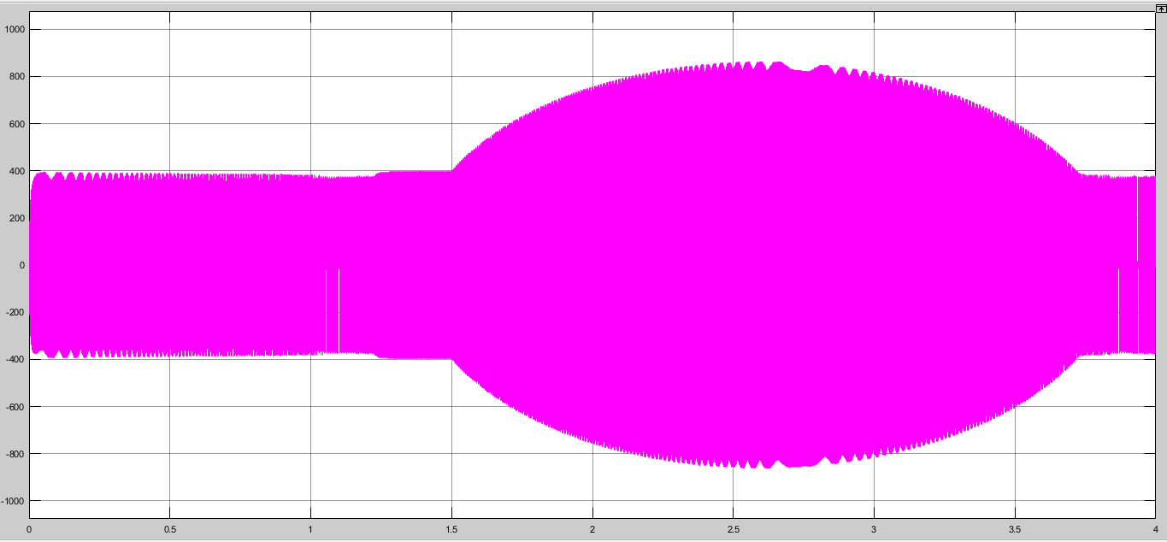

Figure 12. Vl-l Waveform

As it can be seen here, line to line voltage value increases over 800 Volts,peak and this can be dangerous.

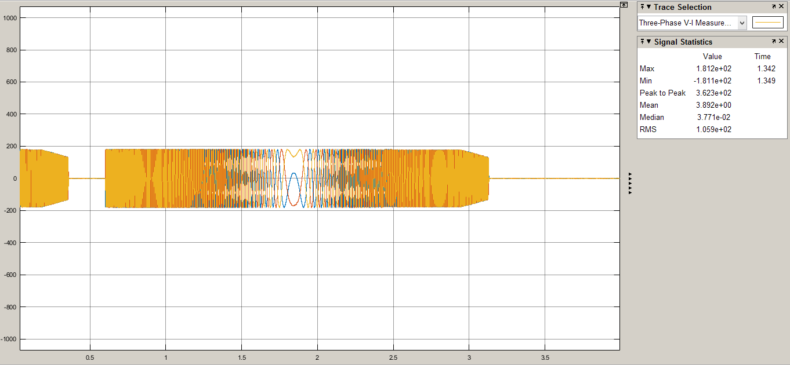

Figure 13. Iphase vs. Time

Irms = 127 Arms;

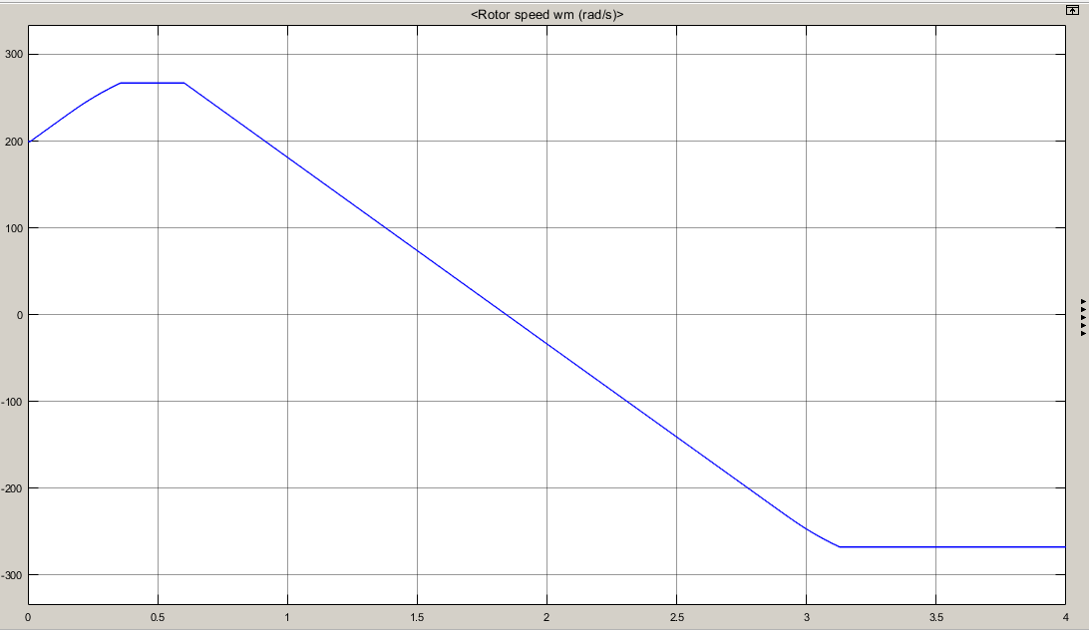

Figure 14. Speed vs. Time

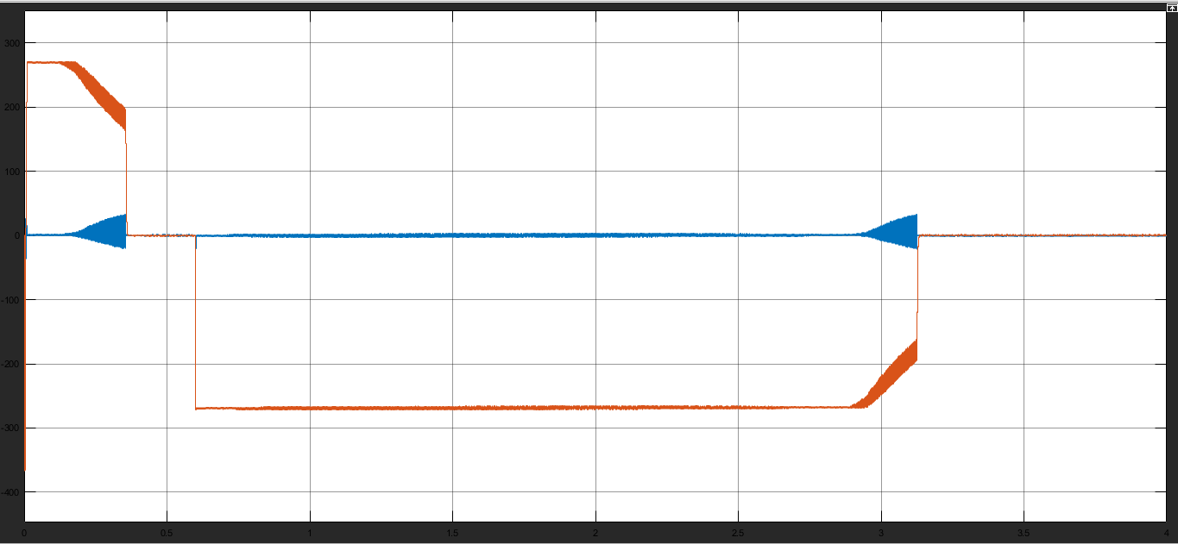

Figure 15. Iq and Id Currents

When the speed of the motor decreases to zero in inverse speed operation,

**4)**

We must use field weakening here to lower the K*flux value because in this region motor’s power is constant and in order to change increase the speed, we must lower the K*flux value.

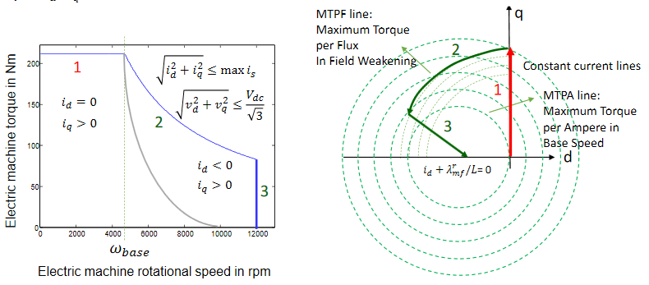

Figure 16. Torque vs. Speed and q-d Coordinates for the Motor Operation

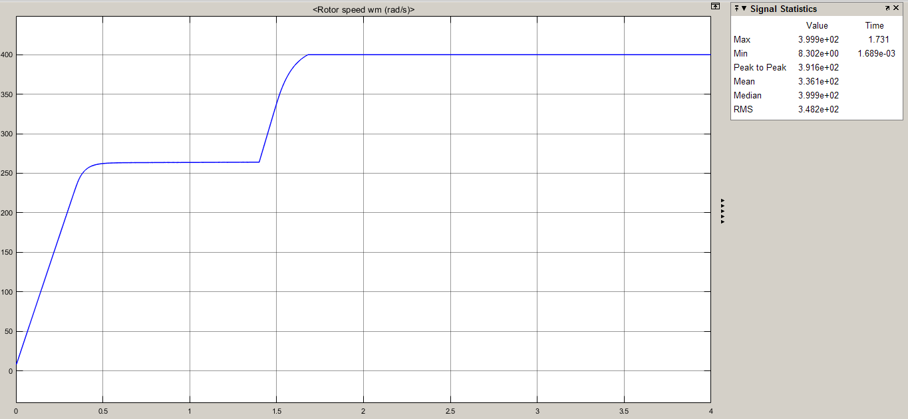

Figure 17. Speed of the Motor after the Controller Operation

In order to get into the field weakening mode, we need to increase the Id value. We observed that when we get the value of the Id to -300, we go straight to 400 rad/s which is 150% rated speed of the motor.

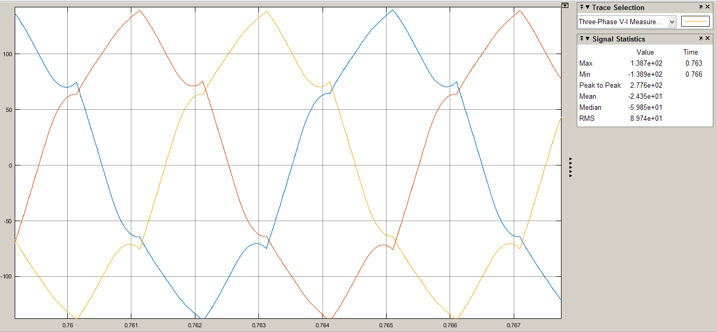

Figure 18. 3-Phase Current When at Rated Speed

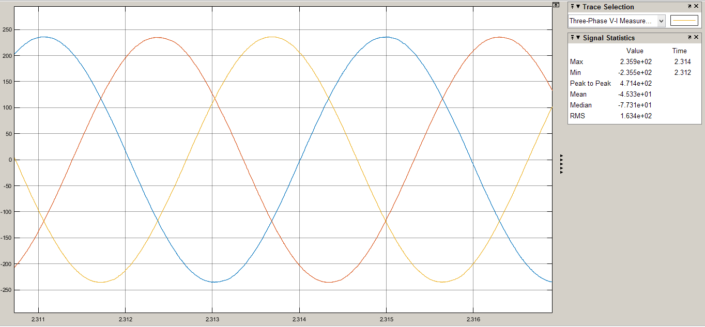

Figure 19. Iphase when at 150% Rated Speed

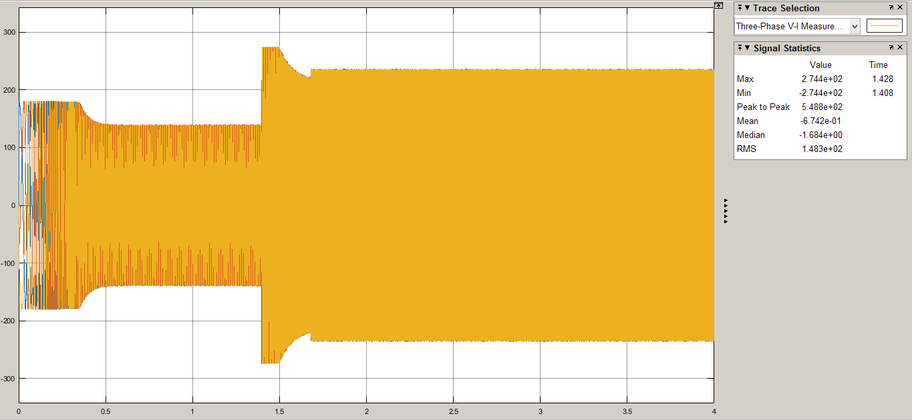

Figure 20. 3-Phase Current Waveforms

As it can be seen from the Figure 19, Iphase,peak = 236 Apeak which is below rated current.

# Part D: Component selection and verification

**1)** As specified in part b, 3rd question of the project briefing, We will have a braking resistance which will limit our DC-Link voltage at the inverter at most to 600 Vdc so our Mosfets and Diodes must have a voltage rate higher than this voltage value. Also our rated current is 250 Apeak.

For 3-Phase Full Diode Rectifier, we managed to find a high current diode rectifier which is not a 3-Phase Rectifier but still gets the job done if 6 of it bought. MDO500-12N1 High Current Diode Rectifier is chosen for the 3-Phase Diode Rectifier. This rectifier has a 1200 Volt and 560 Amps Rated values. Datasheet can be found at the end of this report.

For the DC Link capacitor, C44UOGT7200G5SK was used with a 900 Volts capability.

For the inverter, a FF150R17KE4 IGBT was used which has 1700 Volt rating and 150 A, as for inverter’s current for each IGBT was around 80-100, this choice was sufficient.

Loss in DC Link Cap is equal to 0.2 Watt which we will ignore.

All of these product’s datasheets can be found at the end of the page.

**2)** For IGBT, 102 mJ per cycle was lost in total of switch on and off which results in approximately 1020 Watt for 10kHz switching freq and with. Formula for the loss calculation ;

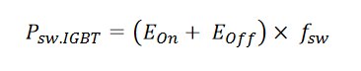

Figure . Switching Total Power Loss Calculation Provided by Dynex Semiconductors

Also conduction losses must taken into account for IGBTs and others. Vce,sat = 2.35 V in IGBT and Ic was approx. 87 Amperes so, 2.35 * 87 = 204.45 Watts. For the whole 1224.45 *6 = 7346.7 Watt Losses for IGBTs.

For diode rectifier, Vfor = 1 Volt and considering approx. 203 Ampere,RMS dissipates through diodes, 203 Watt loss per diode rectifier results in a 2.6 kW loss for both using in rectifier and inverters makes it 13 diodes with the added diode in the Braking Resistance.

All in all at overall 10 kWatts are lost for this system coming from the semiconductor devices which takes away 12.5% away from the total power.

**3)** Loss in here is almost same as in the part 2, not much of a detail given about PMSM that’s why we said that copper and core losses can be ignored and Rs loss is 0.05 * 250 = 12.5 Watt which is ignored.

Efficiency = 87.5 % for our simulation but we can say that this is definitely not the case when a real PMSM machine comes in, this efficiency will be much smaller.

# References

Help for the loss calculations taken from here: [**https://www.dynexsemi.com/assets/downloads/DNX_AN6156.pdf**](https://www.dynexsemi.com/assets/downloads/DNX_AN6156.pdf)

**Datasheets**

**IGBT:** [**https://eu.mouser.com/datasheet/2/196/Infineon-FF150R17KE4-DS-v02_03-EN-219268.pdf**](https://eu.mouser.com/datasheet/2/196/Infineon-FF150R17KE4-DS-v02_03-EN-219268.pdf)

**Single Diode Rectifier:** [**https://eu.mouser.com/datasheet/2/240/MDO500-12N1-1549412.pdf**](https://eu.mouser.com/datasheet/2/240/MDO500-12N1-1549412.pdf)

**DC Link Capacitor:** [**https://eu.mouser.com/datasheet/2/212/kemet_10262015_C44UOGT7200G5SK-1173033.pdf**](https://eu.mouser.com/datasheet/2/212/kemet_10262015_C44UOGT7200G5SK-1173033.pdf)